**Cut out the template as below**

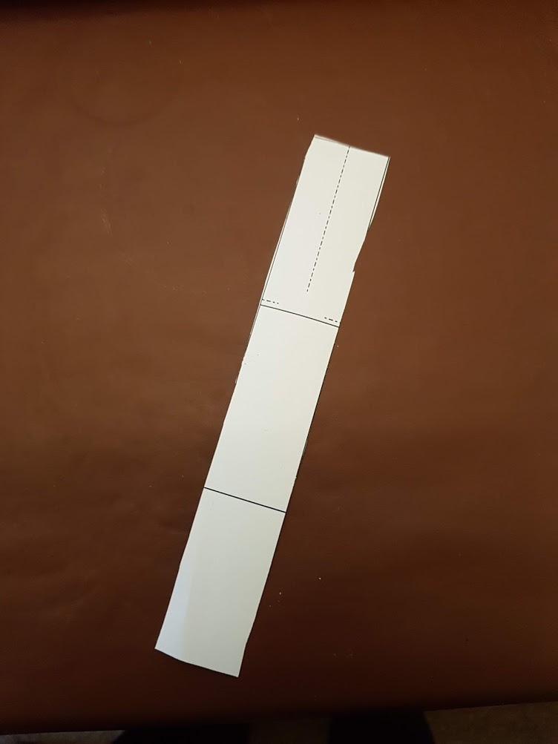

**Snip along the dotted lines and fold inwards**

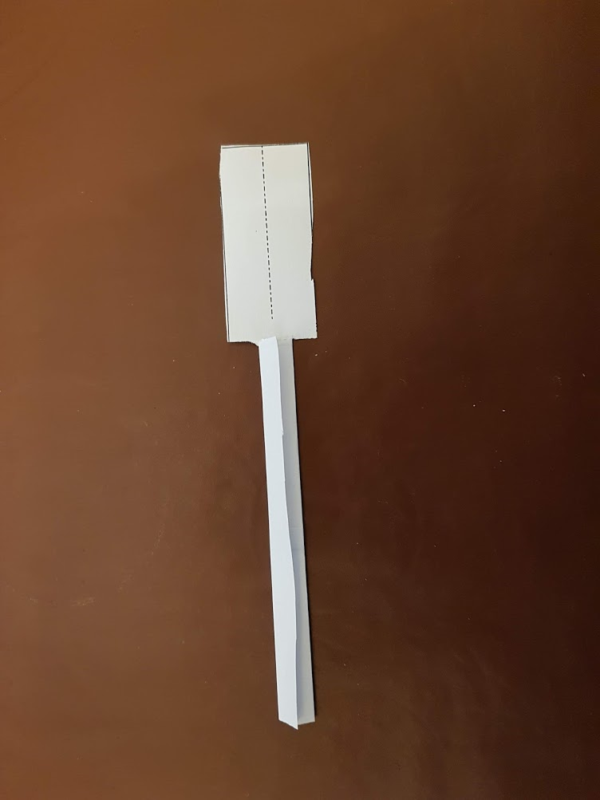

**Fold the tail upwards (how far is up to you) and secure with one (or more) paper clips**

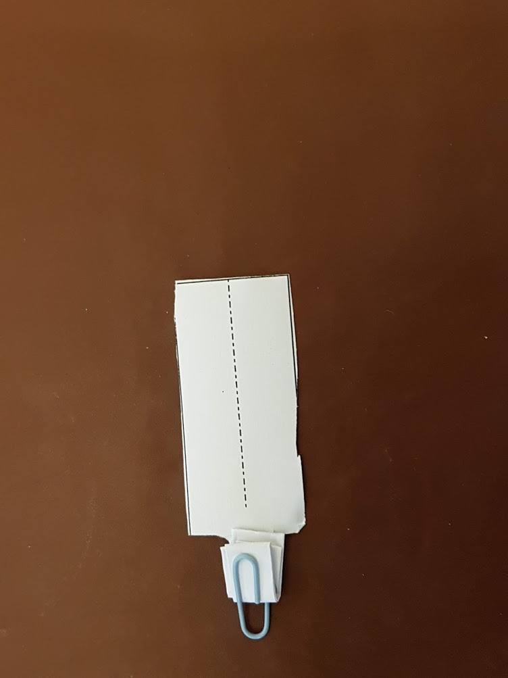

**Snip along the dotted line and fold outward to make the blades. Try twisting slightly to add pitch for great lift**

